Group 2

Integrated Campus | SEN-Winter 2013

Integrated Campus

Student Survey Analysis

February 13, 2013

**Revision History:**

|  |  |  |  |  |
| --- | --- | --- | --- | --- |
| **Version** | **Primary Author(s)** | **Description of Version** | **Reviewed By** | **Date Completed** |
| V_1.0 | Ayush Jain | This is the first version of the student analysis | Sushant Pritmani, Anubhav Maity | 13-02-2013 |

Contents:

Methodology

Questionnaire and the Responses

Analysis

Conclusion

Methodology:

For the success of any project, we need to be clear about what our end user’s needs are, what they want and how they want? So survey and analysis play major part in deciding, what are the things that we should focus on for the success of the project.

For the purpose of survey and analysis we decided to use two main means to gather information from users (students), they were:

* Person-to-Person Interaction
* Online Survey

We circulated the questionnaire using webmail as the main source, and decided to personally interact with some of the students so that we can get better clarity about what they want, and what are their expectations from us. For interaction purposes we decided to target students from every batch, so that we can target the needs of maximum students.

Our questionnaire was prepared keeping in mind the current deployed system, to find out the means of interaction that students are using to interact with their seniors and faculty members regarding academic issues, and what are the changes that can be made to improve the current scenario.

At the completion of survey and analysis, we were successful in collecting about 140 responses through the questionnaire we circulated, and about 40 responses by individual interaction.

The questionnaire was prepared by Ayush Jain, Vipul Garg and Anubhav Maity, and the responsibility to interact with individual was given to Sushant Pritmani, Dishant Patel. The remaining five members were assigned the responsibility of collecting responses from faculty members.

Questionnaire and the Responses:

In this section we will be discussing in detail why each question was part of our questionnaire, and what we infer from the responses given by the students.

Question 1.

**What do you find to be the best way to interact with Faculty?**

* Appointment
* Webmail
* After Lecture
* Forum, like on Moodle

Responses:

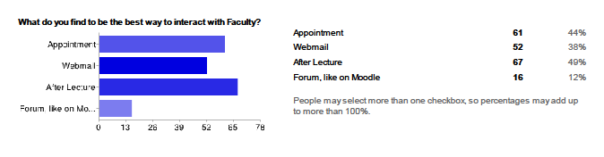

Purpose:

The main purpose of adding this question in the questionnaire was to find out what people found the most appropriate way to interact with the faculty. With the help of this we want to analyse the current scenario, and how can we by our project help users (student/faculty) to interact with each other.

This question will also help in cross analysing the responses which we get from students and faculties.

Question 2.

**Would you like to have a platform to interact with Faculty?**

* Yes
* No

Responses:

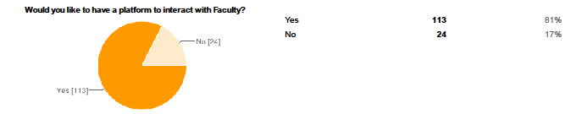

Purpose:

The purpose of including this question was to find out that the students are satisfied with the current system, or do they want changes in the current system. This also supports us to the previous question to find out what the students want.

Question 3.

**According to you which is the best way to get the course material?**

* Webmail
* Intranet
* Courses

Responses:

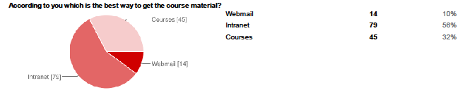

Purpose:

This was added to find out that what are students currently using and what they prefer to get access to the course material. This will also help in cross checking the responses we get from student and faculty, which will help in answering questions like: what and why the faculties think is the best for them to upload the course material, and what students think is the best way.

Question 4.

**Do you find occasional changes in lecture timing inconvenient?**

* Yes
* No

Responses:

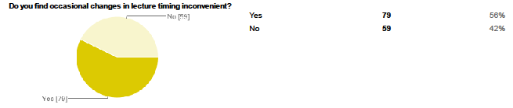

Purpose:

The purpose was to find out whether students feel that, changing the lecture timing is inconvenient, so that we can add some features to our timetable module to help them.

Question5 & 6.

**Do you interact with your seniors about academic issues?**

* Most of the time
* Occasionally
* Never

**If not, what are the reasons?**

* Doesn't matter
* Seniors are inaccessible
* Lack of means of interaction
* Other:

Responses:

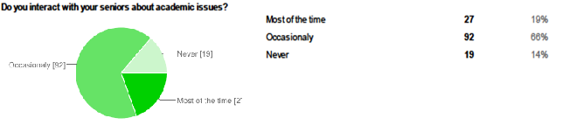

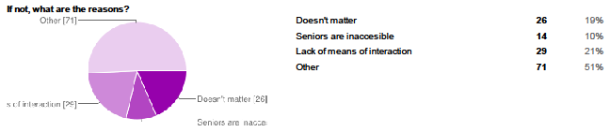

Purpose:

To find out the interaction pattern between students and their seniors. It will also help us to find out what are the reasons students don’t interact with seniors.

Question 7.

**What do you think about having a platform for interacting with the student community about academic issues?**

* It would be great
* Current means are sufficient
* It may help
* Other:

Responses:

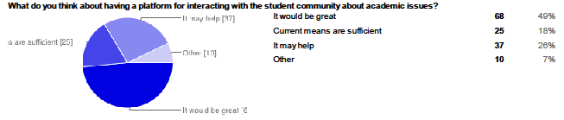

Purpose:

This was in continuation with the above two questions, to find out whether the students want a common platform where they can interact with the student community regarding academic issues, and are they satisfied with the current ways of interaction.

Question 8.

**Which type of interaction do you think would be academically more productive?**

* Student - Student interaction (without faculty intervention)
* Student - Student interaction (with faculty involvement)
* Other:

Responses:

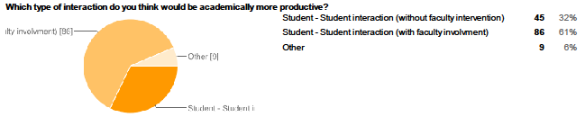

Purpose:

This was added to find out whether the students want a separate discussion forum for the inter student interaction, or they also want faculty member to give their inputs.

Question 9.

**Any problems faced by you in academic context?**

Purpose:

This was added so that students can give suggestions related to academic problems and that we can solve with the help of our software.

Analysis:

From the survey done by us we can found that many students at present feel that the best way to interact with the faculty members is by taking appointment, through webmail, or after lecture. Very few students are using moodle to interact with the faculty members. From the next question we can find that many students want a platform like moodle to interact with faculty members, this makes us infer that the current deployed system is not helping many of the students, so we plan to implement a discussion forum where students can interact with faculties and can clear their course related doubts also.

We also found that students feel intranet a better way to access files related to course material, but due to the inaccessibility from outside college, they want a platform from where they can access course related material from outside the college also, this is recently deployed in the moodle but faculties aren’t satisfied with the performance, so we will try to improve the performance. (this was found when we took individual responses from the students).

Many student also feel the need to have a common platform where the whole student community can interact with each other related to academic issues. The students also feel that intervention of faculty members will be more productive.

Students also feel that due to the changes in lecture timings it happen sometimes that they miss the lectures, so for that we will try to implement a time table module which will keep you updated regarding any changes in timing.

Conclusion

* We will be implementing a discussion forum for interaction between students and faculty members
* We will be implementing the file upload feature so that students can access course related material from outside the campus, and faculty members can ask students to upload assignments.
* We will be implementing time table features also.